**Question E:**

I have an app that displays all people. It uses handlebars and MongoDB as it’s database.

My issue is when I try to display all users which should look like this:

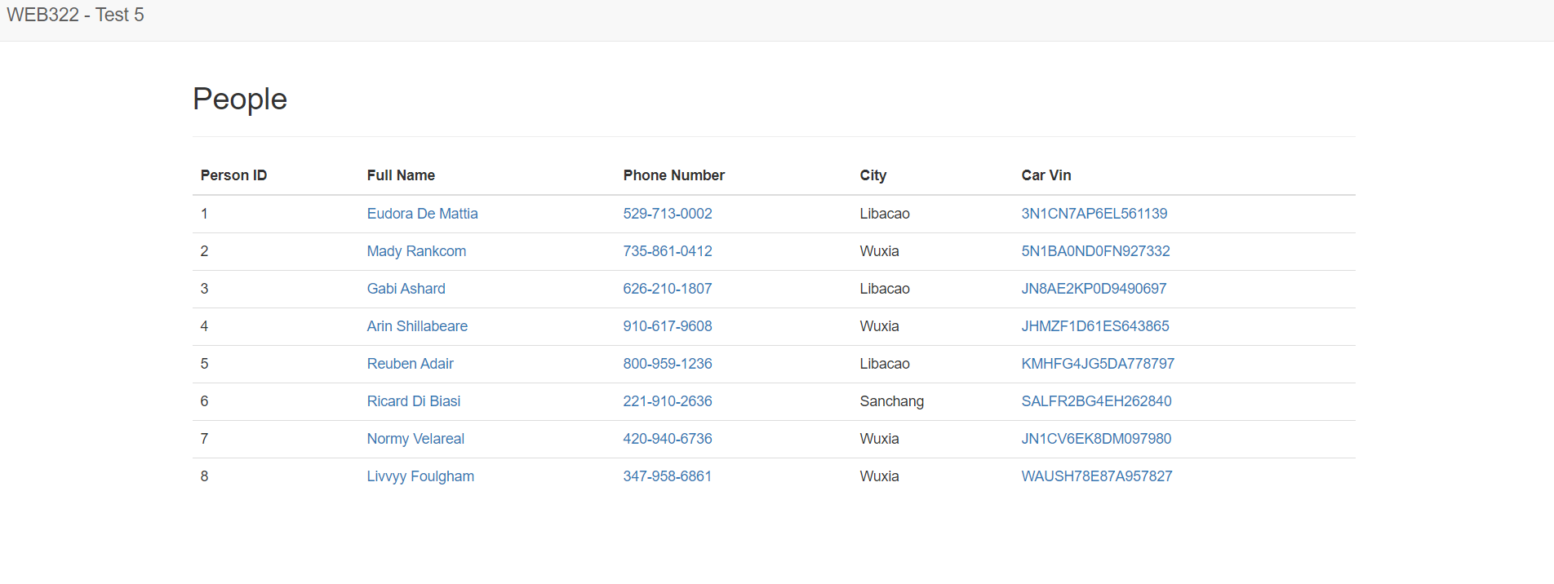

I only get this:

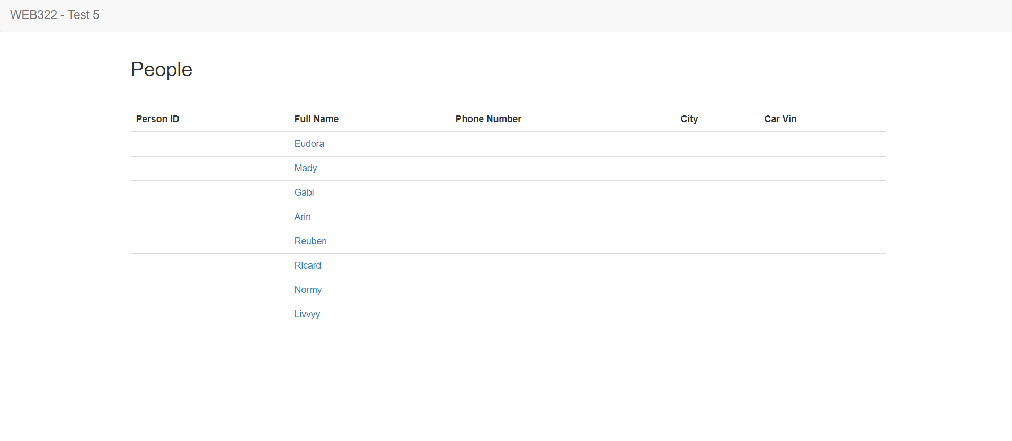

Using the provided Handlebars page, route and data-service snippet. Tell me:

**What is the problem** and **how can I fix it?**

Note: We can assume the server and the database is set up correctly as well as handlebars.